Analyzing Roller Coasters Using Work and Mechanical Energy

Refer to the following diagram to answer the questions that follow. The mass of the car and its riders is 500kg. The height of the starting hill is 15.0m, and the car has a speed of 0 m/s at that point. Assume no work done by non-conservative forces until point D. The car must stop by E.

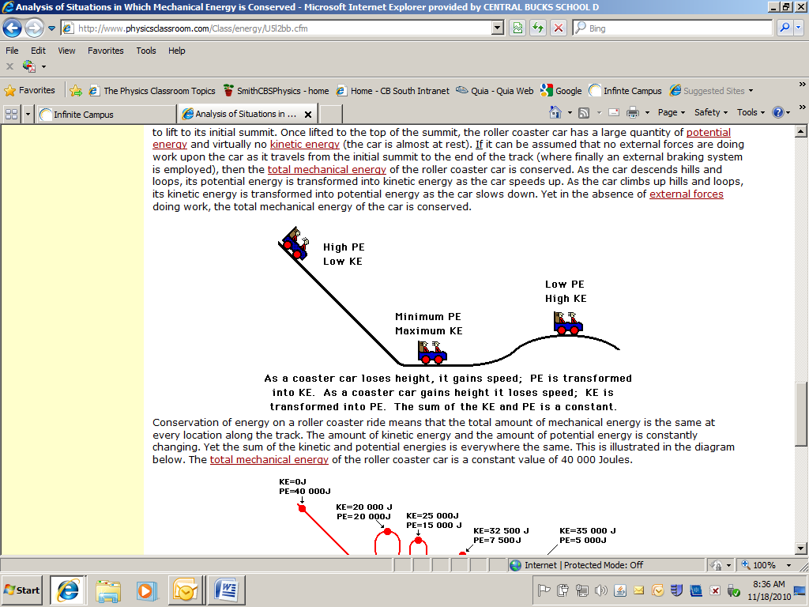

1. Determine the PE at the start (point A).
2. In moving from A to B, what kind of energy transfer takes place? (PE to KE or KE to PE or ME to…) What force does work to transfer energy?
3. Determine the KE of the car at point B.
4. Determine the speed of the car at point B.
5. In moving from B to C, what kind of energy transfer takes place? (PE to KE or KE to PE or ME to…) What force does work to transfer energy?
6. Determine the speed of the car at point C (height = 5.0m).
7. In moving from C to D, what kind of energy transfer takes place? (PE to KE or KE to PE or ME to…) What force does work to transfer energy?
8. Determine the speed of the car at point D.
9. In moving from D to E, what kind of energy transfer takes place? (PE to KE or KE to PE or ME to…) What force does work to transfer energy?
10. Determine the work that friction must do to stop the car between D and E.
11. Determine displacement from D to E if 2450N of friction are available to stop the car.
12. Determine the work that friction must do to stop the car between D and E.
13. Determine displacement from D to E if 2450N of friction are available to stop the car.